 | Filing Reference : |  | GG/COMS/TS.2/11
 | Document Title : |  | Use-Case Realization Report (Analysis)  Manage Sales Order
 | Version : |  | 1.0
 | Prepared By : |  | Koh Ming Jin
 | Date Created : |  | Monday, Jul 15th, 2011
Approved By :
 |  | Tran Ba Tien |  | Date
 |  | Project Manager |  | 15th Jul 2011
©2011 [Hoang Kim joint stock Company].
The information contained in this document is the property of [Hoang Kim joint stock Company]. The contents must not be reproduced, wholly or in part, for purposes other than for which it has been supplied, without the prior permission of [Hoang Kim joint stock Company], or, if it has been furnished under contract to another party, as expressly authorised under that contract. [Hoang Kim joint stock Company] shall not be liable for any errors or omissions.

Revision History
Date | Issue | Description | Author
15/Jul/2011 | 1.0 | Initial Document | Koh Ming Jin

Table of Contents
1. Brief Description 4
2. Flow of Events 4
2.1 Standard Flow 4
2.1.1 Creation of Sales Order 4
2.1.2 Update / deletion of Sales Order codes 4
2.2 Exception 4
3. Interaction Diagrams 4
3.1 Collaboration Diagram for Manage Sales Order 4
4. Participating Objects 6
4.1 Create Sales Order Page 6
4.2 Update Sales Order Page 6
4.3 Delete Sales Order Page 6
4.4 Role Main Page 6
4.5 Sales Order Controller 6
4.6 Cylinder Controller 6
4.7 Sales Order 6
4.8 Sales Order Detail 6
4.9 Cylinder 6
5. Class Diagrams 6
5.1 Domain Class Diagram: Manage Sales Order 6
6. Derived Requirements 8

Use-Case Realization Report
Manage Sales Order

Brief Description
This use case enables a Sales Staff to manage Sales Order records. Managing Sales Order records includes creating, updating and deleting of Sales Order records. The required information includes the Sales Order ID, Sales Order number, ordered items information and Sales Order customer information.

Flow of Events
The standard flow of events for this use case and any exceptions are described in the following subsections. See section 3.1 for an overview of the participating Actors and Domain Objects.

Standard Flow
The flow of events is described as follows:

- The use case starts when the authenticated Sales staff selects the Manage Sales Order option of the system.
- The Manage Sales Order Page is displayed.

Creation of Sales Order
- The Sales Staff provides all the required details (e.g. Cylinder order & Customer information) concerning a new Sales Order into the Manage Sales Order Page.
- The Sales Order will be submitted to the backend server and stored in the database.
- The use case terminates.

Update / deletion of Sales Order codes
- The Sales Staff provides the Sales ID concerning an existing Sales Order into the Manage Sales Order Page and submit to retrieve the Sales Order information.
- The existence of the Sales Order in the system is checked against the Sales Order information held by the database.
- If the Sales Order ID is in the current database and the selected option is to either delete or update,
  - The selected Sales Order record will be updated with the supplied details.
  - The selected Sales Order record will be deleted.
- The use case terminates.

Exception
- The Sales Order ID does not exist for update or delete option. If the input Sales Order ID is not found to be an existing one, the Sales Order modification or deletion will fail. An error message will be displayed, and subsequently redirect to the Manage Sales Order Page.

Interaction Diagrams

Collaboration Diagram for Manage Sales Order

Create Sales Order

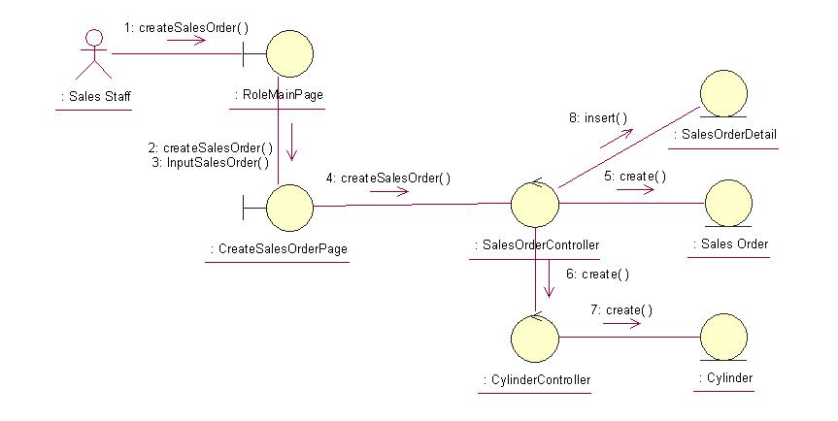
Update Sales Order

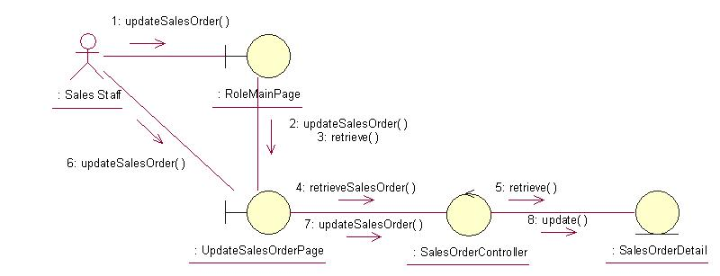

Delete Sales Order
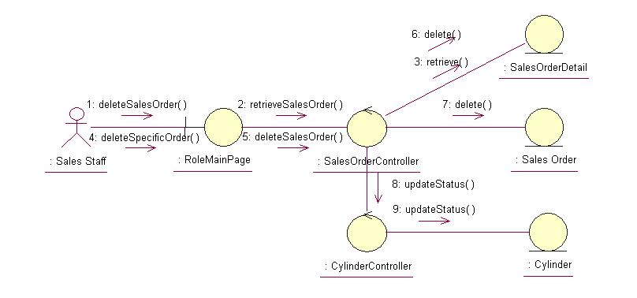

Participating Objects

Create Sales Order Page
This object renders the contents to allow authorized actors to perform the create Sales Order requests. The Sales Staff actor uses this object.

Update Sales Order Page
This object renders the contents to allow authorized actors to perform the update Sales Order requests. The Sales Staff actor uses this object.

Delete Sales Order Page
This object renders the contents to allow authorized actors to perform the delete Sales Order requests. The Sales Staff actor uses this object.

Role Main Page
This object renders the contents to allow the authorized Sales staff actor to perform his or her jobs.

Sales Order Controller
This object acts as the middleman between related Sales Order Pages and the Sales Order and Sales Order Detail objects. It will translate interactions with the view into actions to be performed by the Sales Order or Sales Order Detail objects.

Cylinder Controller
This object acts as the middleman between Sales Order Controller and the Cylinder object. It will translate interactions with the view into actions to be performed by the Cylinder object.

Sales Order
This object stores the details concerning the Sales Order of the COMS.

Sales Order Detail
This object stores the details concerning the Sales Order Detail of the COMS.

Cylinder
This object stores the details concerning the Cylinder of the COMS.

Class Diagrams

Domain Class Diagram: Manage Sales Order

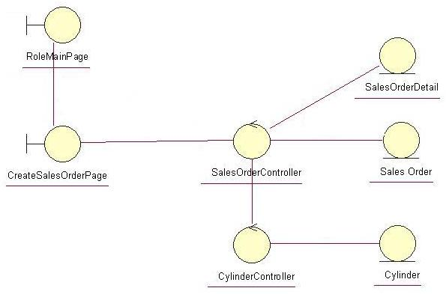

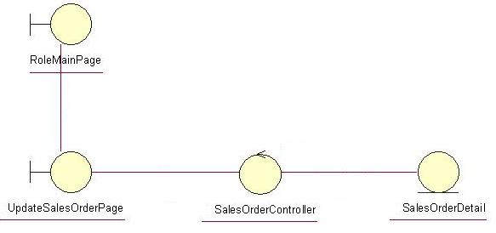

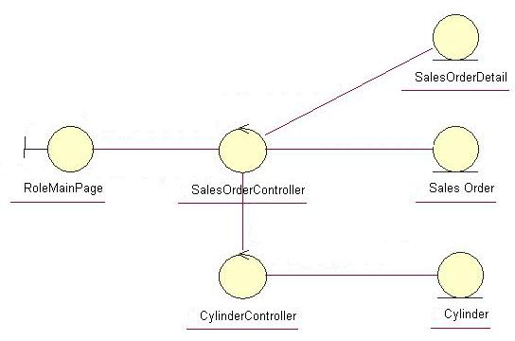

Derived Requirements
The Sales Staff PC keyboard and mouse will be used to enter Sales Order details (if any) and view all the system responses.

